**Playa 1**

/system identity

set name=PLAYA1

/interface bridge

add name=bridge1 vlan-filtering=yes

/interface bridge port

add bridge=bridge1 interface=ether6

add bridge=bridge1 interface=ether5

/interface bridge vlan

add bridge=bridge1 tagged=ether5,ether6,bridge1 vlan-ids=40

add bridge=bridge1 tagged=ether5,ether6,bridge1 vlan-ids=50

/interface vlan

add interface=bridge1 name=vlan50 vlan-id=50

add interface=bridge1 name=vlan40 vlan-id=40

/ip address

add address=192.168.5.1/24 interface=vlan50 network=192.168.5.0

add address=192.168.4.1/24 interface=vlan40 network=192.168.4.0

ip/dhcp-server/setup

/ipv6 address

add address=2001:db8:d:: interface=vlan40

add address=2001:db8:e:: interface=vlan50

=======================================================

/interface bridge

add name=loopback

ip/address/add address=10.0.0.6/30 interface=ether5

ip/address/add address=10.255.255.6 interface=loopback

/routing id

add name=id_ospf select-dynamic-id=only-loopback

/routing ospf instance

add disabled=no name=ospf router-id=id_ospf

add disabled=no name=ospfv3 router-id=id_ospf version=3

/routing ospf area

add disabled=no instance=ospf name=backbone

add disabled=no instance=ospfv3 name=backbone6

/routing ospf interface-template

add area=backbone interfaces=loopback passive

add area=backbone interfaces=vlan40 passive

add area=backbone interfaces=vlan50 passive

add area=backbone interfaces=ether1 type=ptp

add area=backbone6 interfaces=loopback passive

add area=backbone6 interfaces=vlan40 passive

add area=backbone6 interfaces=vlan50 passive

add area=backbone6 interfaces=ether1 type=ptp

**Playa 2**

/system identity

set name=RPLAYA2

/interface bridge

add name=bridge1 vlan-filtering=yes

/interface bridge port

add bridge=bridge1 interface=ether6

add bridge=bridge1 interface=ether1

/interface bridge vlan

add bridge=bridge1 tagged=ether1,ether6 vlan-ids=40

add bridge=bridge1 tagged=ether1,ether6 vlan-ids=50

/ipv6 nd

set [ find default=yes ] ra-interval=10-15

**Playa 3 exactamente igual**

**Chiclana 1**

/system identi

set name=CHICLANA1

/interface vlan

add interface=ether6 name=vlan10 vlan-id=10

add interface=ether6 name=vlan20 vlan-id=20

add interface=ether6 name=vlan30 vlan-id=30

/ip address

add address=192.168.1.1/24 interface=vlan10 network=192.168.1.0

add address=192.168.2.1/24 interface=vlan20 network=192.168.2.0

add address=192.168.3.1/24 interface=vlan30 network=192.168.3.0

/ip dhcp-server

/ipv6 address

add address=2001:db8:a::/64 interface=vlan10

add address=2001:db8:b::/64 interface=vlan20

add address=2001:db8:c::/64 interface=vlan30

==================================================

/interface bridge

add name=loopback

ip/address/add address=10.0.0.6/30 interface=ether1

ip/address/add address=10.255.255.11 interface=loopback

/routing id

add name=id_ospf select-dynamic-id=only-loopback

/routing ospf instance

add disabled=no name=ospf router-id=id_ospf

add disabled=no name=ospfv3 router-id=id_ospf version=3

/routing ospf area

add disabled=no instance=ospf name=backbone

add disabled=no instance=ospfv3 name=backbone6

/routing ospf interface-template

add area=backbone interfaces=loopback passive

add area=backbone interfaces=vlan10 passive

add area=backbone interfaces=vlan20 passive

add area=backbone interfaces=vlan30 passive

add area=backbone interfaces=ether1 type=ptp

add area=backbone6 interfaces=loopback passive

add area=backbone6 interfaces=vlan10 passive

add area=backbone6 interfaces=vlan20 passive

add area=backbone6 interfaces=vlan30 passive

add area=backbone6 interfaces=ether1 type=ptp

**Chiclana 2**

/system identity

set name=RCHICLANA2

/interface bridge

add name=bridge1 vlan-filtering=yes

/interface bridge port

add bridge=bridge1 interface=ether6

add bridge=bridge1 interface=ether1 pvid=10

add bridge=bridge1 interface=ether2 pvid=20

/interface bridge vlan

add bridge=bridge1 tagged=ether6 untagged=ether1 vlan-ids=10

add bridge=bridge1 tagged=ether6 untagged=ether2 vlan-ids=20

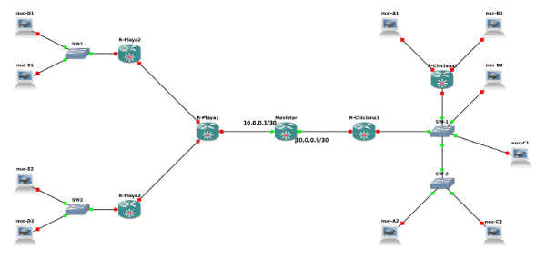

NO HAY PING ENTRE TODOS LOS NUCS